Online access to MVLS Stores

This form must be completed by the budget holder and nominated delegates.
Please return as follows:

Access to Thurso Street Stores
Tracy Devine, MVLS Stores, 6 Thurso St tracy.devine@glasgow.ac.uk
kelly-anne.shields@glasgow.ac.uk

Access to Garscube Stores
Tracy Devine, Level 1, tracy.devine@glasgow.ac.uk
Henry Wellcome Building kelly-anne.shields@glasgow.ac.uk

Please use a separate form for each project you wish to access.

Store (Thurso/Garscube) Thurso

Cost Centre 203

Project number (eight digits) 3232137-01

Does budget-holder require a copy of orders Yes

Default delivery address University of Glasgow, Graham Kerr Building, Science Wy, G12 8QQ

Date of request 13th August 2024

 | Name | Signature | Email | Tel | GUID
Budget holder | Dr Sofie Spatharis |  | Sofie.Spatharis@glasgow.ac.uk | 0141 330 3560 | Ss305n
Delegate 1 | Dr Chris Proudlove |  | Chris.Proudlove@glasgow.ac.uk | 01413302504 | Cjp12d
Delegate 2 | Calum Young | 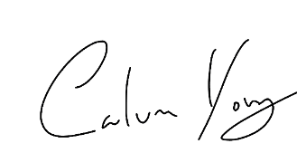 | 2090242Y@student.gla.ac.uk | 07398206954 | 2090242Y
Delegate 3

Delegate 4

